Advanced Analytics: Techniques, Requirements and Use Cases for Data-Driven Businesses
Most analytics teams have spent the last decade getting good at one thing: explaining what already happened. That work is still useful. A clear dashboard saves a team from arguing about vibes, and standard reporting catches obvious problems before they get expensive. But many businesses now want something harder, a defensible guess about what is likely to happen next, on data that lives in too many systems and changes too quickly for spreadsheets. Advanced analytics is the label for that work. It is not magic, and it does not always tell anyone what to do; at its best, it reduces uncertainty enough that a decision becomes less of a gamble.

1. What is Advanced Analytics?
Advanced analytics is the point where analytics stops being only retrospective and starts to become predictive or prescriptive. Traditional business intelligence answers questions like "what happened last quarter" or "which region missed the target". Advanced analytics tries to answer messier ones: "which customers are likely to leave", "what should we reorder before demand spikes", "which transactions look suspicious right now". Under the hood, this is a mix of statistical models, machine learning, text analytics, simulation, optimization, and a lot of data engineering work that nobody puts on the conference slide.
The difference from traditional analytics is not just the tools. A dashboard can be wrong and, in many cases, the damage is limited to a bad meeting. A model that automatically blocks a payment, changes a price, or flags a patient’s risk score has a much larger blast radius. Once analytics starts affecting decisions directly, questions about data quality, governance, explainability, and accountability stop being optional paperwork.
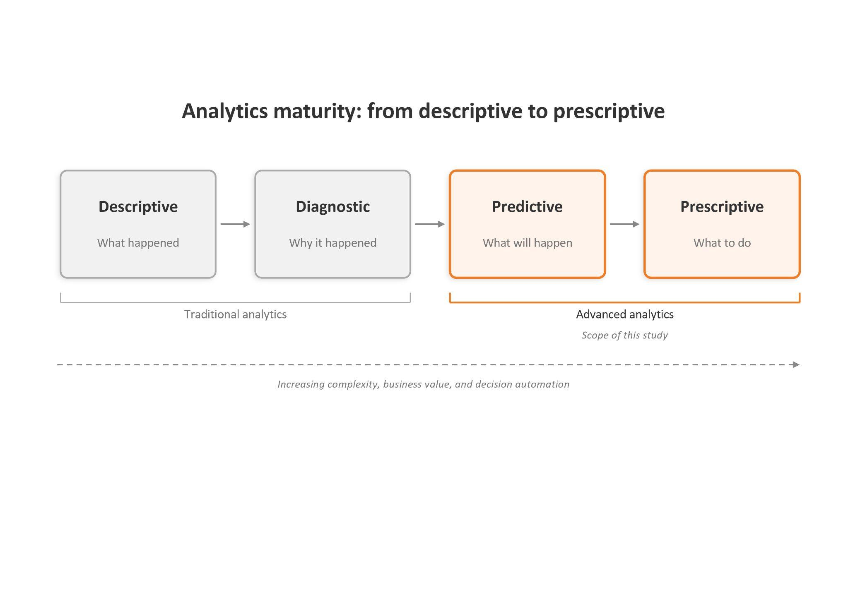
Figure 1: Analytics maturity — from descriptive to prescriptive

2. Advanced Analytics vs. Data Analysis
Traditional analysis and advanced analytics are not competing approaches. They serve different questions. Traditional analysis works mostly with structured data in relational databases, uses SQL and BI dashboards, and produces backward-looking reports. Advanced analytics handles a broader mix: structured tables, semi-structured logs, unstructured text and IoT telemetry, processed through machine learning and statistical models to produce forecasts, recommendations, or automated decisions. Most data-mature organizations run both. BI sets the daily operating cadence, and advanced analytics handles the questions BI cannot reach.
Dimension | Traditional Data Analysis | Advanced Analytics
Data types | Structured, internal databases | Structured, semi-structured, unstructured (IoT, social, documents, images)
Methods & tools | SQL, Excel, BI dashboards | ML, AI, NLP, simulation, statistical modelling, with Python or R as the working language
Decision orientation | Backward-looking (what happened) | Forward-looking (what will happen, what to do)
Output | Reports, dashboards, KPIs | Predictions, recommendations, automated decisions
Primary user | Business analyst, BI team | Data scientist + business user (via self-service tools)

3. Techniques of Advanced Analytics
Advanced analytics is an umbrella for several distinct techniques. Most real deployments combine two or three of them, and most have a failure mode the marketing material does not advertise.
Predictive Analytics. Uses historical data, statistical models, and machine learning to forecast future outcomes such as customer churn, product demand, or credit default risk. Common methods include regression, decision trees, and deep learning, usually built in Python or R. The awkward part is that predictive models often look better in a notebook than in production. Customer behaviour shifts, data pipelines break, and the business team may not act on the prediction anyway. Most predictive projects fail at operationalization, not at modelling.
Prescriptive Analytics. Goes one step further than prediction by recommending the best action under stated constraints. Where predictive analytics says "demand will rise 12% next quarter", prescriptive analytics says "reorder from supplier B by Friday at unit cost X". It uses optimization solvers, simulation, or reinforcement learning, and is most common in pricing, route planning, and resource allocation. The recommendation is only as good as the constraints. Miss a real-world constraint that the operations team treats as obvious, and the system happily suggests something nobody can actually do.
Data Mining. Surfaces patterns, correlations, and unusual segments in large datasets. Classic applications: market basket analysis, customer segmentation, anomaly detection. Modern data mining now overlaps heavily with general-purpose machine learning, and most teams just use Python or R. The risk is finding patterns that look interesting but are statistical noise, or stable historical patterns that no longer hold. A correlation in the data is not the same as a useful business insight.
Big Data Analytics. This is more about scale than method. It deals with the volume, velocity, and variety of modern data using distributed processing frameworks such as Apache Spark and cloud lakehouse platforms. It is the infrastructure layer most other techniques run on top of. For many teams, the practical question is not whether to use Spark, Snowflake, Databricks, or whatever is fashionable this quarter. The harder question is whether the data is clean, accessible, and trusted enough for anyone to build on it.
Text Analytics and Natural Language Processing. Extracts structure and meaning from unstructured text: customer reviews, support tickets, contracts, internal documents. Techniques include sentiment analysis, document classification, named-entity recognition, and topic modelling, with tooling that ranges from open-source libraries to large language models. The limitation worth naming is that domain-specific language is rarely captured well by general-purpose models. Accuracy on legal contracts, medical notes, or technical support tickets often needs domain fine-tuning or labelled data the organization does not have.
Real-Time and Streaming Analytics. Processes events as they arrive rather than overnight in batches. The distinguishing infrastructure is event-streaming platforms like Apache Kafka, plus in-memory processing. It is the right choice when waiting for the next batch is itself the failure mode: blocking a fraudulent transaction at authorization, alerting on an industrial sensor before a machine fails, adjusting a price during a flash demand event. The trade-off is operational complexity. Streaming pipelines have more moving parts and more failure modes, and they require monitoring at a different level than batch jobs do.
Figure 2: Core techniques and their typical applications
Technique | What it does | Typical use case | Common tools
Predictive Analytics | Forecasts future outcomes from historical patterns | Customer churn, demand forecasting, credit default | Python (scikit-learn), R, SAS, Azure ML
Prescriptive Analytics | Recommends optimal actions given constraints | Pricing, route optimisation, resource allocation | Gurobi, IBM CPLEX, reinforcement learning libraries
Data Mining | Surfaces hidden patterns and associations | Market basket analysis, customer segmentation | Python, R, RapidMiner, KNIME
Big Data Analytics | Processes large, mixed-format data at scale | Log analysis, IoT telemetry, web-scale event data | Hadoop, Spark, Snowflake, Databricks
Text Analytics & NLP | Extracts meaning from unstructured text | Sentiment analysis, document classification, ticket routing | spaCy, Hugging Face, Azure Cognitive Services
Real-Time / Streaming Analytics | Processes events as they arrive, sub-second latency | Fraud detection, predictive maintenance alerts, dynamic pricing | Apache Kafka, Apache Flink, AWS Kinesis

4. Requirements for Business Implementation
Most advanced analytics projects do not fail because the model was not sophisticated enough. Gartner found that, on average, only 48% of AI projects make it into production, with an average eight-month gap between prototype and live deployment [3]. RAND’s 2024 report is even blunter: by some estimates, more than 80% of AI projects fail, roughly twice the failure rate of non-AI IT projects [4]. The reasons are usually mundane: bad data, unclear ownership, weak business alignment, and nobody quite knowing who is supposed to maintain the thing after the demo.
Technical foundation. A working stack needs consolidated data infrastructure (warehouse, data lake, or modern lakehouse), elastic compute, modelling environments, visualization tools, and access controls embedded at the data layer. The boring truth is that input data is usually scattered across five or six systems, half the columns mean different things in different departments, and nobody knows whether "active customer" means logged in this month, paid this month, or simply not deleted from the CRM. Before a company can talk seriously about machine learning, it needs a usable data foundation. Otherwise the data science team ends up doing archaeology with SQL.
People and governance. A production analytics system needs more than a data scientist with a good notebook. It needs data engineers to move and clean the data, ML engineers to deploy and monitor models, domain experts to sanity-check the output, and a governance function to ask the questions about privacy, bias, and accountability that nobody on the technical team wants to ask. For European organizations, GDPR sets the baseline for personal data, and the EU AI Act adds a second layer covering model risk classification, transparency, and human oversight. The penalty structure is worth stating carefully: the most serious violations, such as prohibited AI practices, can reach EUR 35 million or 7% of worldwide annual turnover, while many other violations, including high-risk AI obligations, fall under a lower ceiling of EUR 15 million or 3% [5].
Business prerequisites. A narrowly defined use case matters more than any tool. Executive sponsorship, agreed KPIs, and willingness to act on model outputs separate the projects that ship from the ones that stall in proof-of-concept. Gartner predicts that at least 30% of generative AI projects will be abandoned after proof of concept by the end of 2025, citing poor data quality, inadequate risk controls, escalating costs, and unclear business value [6].
Cost considerations: when is it worthwhile. Advanced analytics scales with data volume, talent, and decision frequency. As a directional rule, an organization with under a few million records, infrequent decisions, and no dedicated data team will get more value from better BI than from machine learning. The economics flip when datasets reach the tens or hundreds of millions of records, when decisions occur daily or hourly, or when each decision carries material euro impact. Financial services, manufacturing, retail, telecommunications, healthcare, and logistics fit this profile most cleanly.
What you actually get. Against the right use case, advanced analytics compresses decision cycles, raises forecast accuracy, and supports decisions that traditional BI is too slow or too passive to handle. The win is rarely one heroic project that saves the company. It is more boring than that: fewer bad stock decisions, fewer false fraud alerts, fewer machines failing without warning. Boring is usually where the operational money is.

5. Use Cases
The four examples below show how the techniques in Section 3 combine on real business problems, and where they tend to fail.
Financial Services: Fraud Detection. Banks and payment providers must block fraudulent transactions in milliseconds while fraud patterns shift constantly. Predictive analytics scores each transaction against historical fraud signatures, and real-time streaming infrastructure runs that scoring inline with the authorization flow. The under-discussed problem is false positives. Research on payment fraud prediction has reported false-positive rates as high as 10–15%, with only about one in five transactions declared as fraud turning out to be truly fraudulent [7]. That is the part the demo usually skips. Wrongly declined customers can cost merchants more than the fraud they were trying to prevent, especially when the customer gives up after the third “suspicious” transaction that was actually just them buying shoes at midnight. The real value is not just catching fraud; it is catching enough of it while keeping false positives low enough that good customers do not abandon the merchant after the third bad decline.
Manufacturing: Predictive Maintenance. This is the use case with the cleanest ROI story in the set, although “clean” still does not mean easy. Sensor telemetry from machines streams into a big-data platform, and predictive models flag early signatures of bearing wear, thermal drift, or vibration anomalies before failure. McKinsey reports that predictive maintenance can reduce machine downtime by 30–50% and increase machine life by 20–40% [8]. Deloitte cites a chemical-manufacturing pilot where predictive capabilities on extruders reduced unplanned downtime by 80% and saved around USD 300,000 per asset [9]. Those numbers are useful, but they are not plug-and-play ROI. A plant with modern sensors and clean maintenance logs is playing a different game from a factory where half the machines are older than the data team. Industry benchmarks often cite unplanned downtime at around USD 260,000 per hour in manufacturing, with automotive plants reaching multimillion-dollar hourly losses [10]. Year one is often less about fancy modelling and more about fixing data pipelines, instrumenting older machines, and convincing the maintenance crew that the model is worth listening to.
Retail: Demand Forecasting. Retailers must decide how much of each product to stock, where, and at what price, often across thousands of SKUs. Predictive models forecast demand at the SKU-region-week level, and prescriptive models recommend reorder quantities and prices subject to inventory and margin constraints. McKinsey research suggests AI-driven forecasting can reduce forecast errors by 20–50%, lost sales and product unavailability by up to 65%, and warehousing costs by 5–10% [11]. Those numbers come from organizations with usable data foundations: master data clean enough to model, sales history long enough to be statistically meaningful, and external signals such as promotion calendars and weather integrated into the forecast. Many retailers are not losing to bad algorithms. They are losing to messy SKU data, missing promotion history, and inventory systems that do not agree with each other. IHL Group projected the global cost of inventory distortion at USD 1.77 trillion in 2023, including USD 1.2 trillion from out-of-stocks and USD 562 billion from overstocks [12]. That number is a useful reminder that the gap between theoretical ROI and realized ROI usually lives inside boring operational data.
Healthcare: Patient Risk Stratification. Hospitals and insurers want to identify which patients are most likely to deteriorate, be readmitted, or develop a chronic condition. Predictive models combine structured clinical data, such as vital signs, lab results, and prescriptions, with text analytics applied to clinical notes. Sepsis prediction models built on electronic health records have reached AUROC values of 0.88 at sepsis onset, 0.84 twenty-four hours before onset, and 0.83 forty-eight hours before onset, outperforming traditional rule-based scoring systems in that study [13]. In a prospective multi-site study of Johns Hopkins’ TREWS system, provider-confirmed alerts within three hours were associated with a 3.3 percentage-point absolute reduction, or 18.7% relative reduction, in in-hospital mortality [14]. The practical bottleneck is rarely only the model. It is whether clinicians trust the alerts enough to act on them, and whether the alert arrives in a workflow where acting is possible. In the EU, many AI systems intended for medical purposes are likely to fall into the high-risk category, which raises requirements around risk management, data quality, transparency, and human oversight [15].

Conclusion
Advanced analytics is a set of techniques, not a turnkey solution. It pays off when an organization has data worth modelling, decisions worth improving, and the discipline to maintain the system after the launch presentation. The techniques themselves are easier to access than ever, between cloud infrastructure, open-source tooling, and capable AI models. Using them well is still hard. The real questions are no longer technical: Which problem to point the analytics at? Who is accountable for the resulting decisions? And how to stay compliant under frameworks like the EU AI Act? The projects that succeed will be the ones that treat advanced analytics as a capability to be built, not bought.
REF
[1] IBM, “What is advanced analytics?” IBM Think. Accessed: Apr. 30, 2026. [Online]. Available: https://www.ibm.com/think/topics/advanced-analytics
[2] Amazon Web Services, “What is Advanced Analytics?” AWS. Accessed: Apr. 30, 2026. [Online]. Available: https://aws.amazon.com/what-is/advanced-analytics/
[3] Gartner, “Gartner Survey Finds Generative AI is Now the Most Frequently Deployed AI Solution in Organizations,” May 7, 2024. Accessed: Apr. 30, 2026. [Online]. Available: https://www.gartner.com/en/newsroom/press-releases/2024-05-07-gartner-survey-finds-generative-ai-is-now-the-most-frequently-deployed-ai-solution-in-organizations
[4] RAND Corporation, “Why AI Projects Fail and How They Can Succeed,” Aug. 13, 2024. Accessed: Apr. 30, 2026. [Online]. Available: https://www.rand.org/pubs/research_reports/RRA2680-1.html
[5] European Union, “Article 99: Penalties,” EU Artificial Intelligence Act. Accessed: Apr. 30, 2026. [Online]. Available: https://artificialintelligenceact.eu/article/99/
[6] Gartner, “Gartner Predicts 30% of Generative AI Projects Will Be Abandoned After Proof of Concept By End of 2025,” Jul. 29, 2024. Accessed: Apr. 30, 2026. [Online]. Available: https://www.gartner.com/en/newsroom/press-releases/2024-07-29-gartner-predicts-30-percent-of-generative-ai-projects-will-be-abandoned-after-proof-of-concept-by-end-of-2025
[7] R. Wedge, J. M. Kanter, S. M. Rubio, S. I. Perez, and K. Veeramachaneni, “Solving the ‘false positives’ problem in fraud prediction,” arXiv preprint arXiv:1710.07709, 2017. [Online]. Available: https://arxiv.org/abs/1710.07709
[8] McKinsey & Company, “Manufacturing: Analytics unleashes productivity and profitability,” Aug. 14, 2017. Accessed: Apr. 30, 2026. [Online]. Available: https://www.mckinsey.com/capabilities/operations/our-insights/manufacturing-analytics-unleashes-productivity-and-profitability
[9] Deloitte, “Predictive maintenance and the digital supply network,” May 9, 2017. Accessed: Apr. 30, 2026. [Online]. Available: https://www.deloitte.com/us/en/insights/industry/manufacturing-industrial-products/industry-4-0/using-predictive-technologies-for-asset-maintenance.html
[10] ReliaMag, “The Real Cost of Unplanned Downtime in Manufacturing,” Apr. 2026. Accessed: Apr. 30, 2026. [Online]. Available: https://reliamag.com/articles/cost-unplanned-downtime-manufacturing/
[11] McKinsey & Company, “AI-driven operations forecasting in data-light environments,” Feb. 15, 2022. Accessed: Apr. 30, 2026. [Online]. Available: https://www.mckinsey.com/capabilities/operations/our-insights/ai-driven-operations-forecasting-in-data-light-environments
[12] Blue Yonder, “Retail Inventory Distortion Report.” Accessed: Apr. 30, 2026. [Online]. Available: https://blueyonder.com/resources/retail-inventory-distortion-report
[13] C. Barton et al., “Evaluation of a machine learning algorithm for up to 48-hour advance prediction of sepsis using six vital signs,” Computers in Biology and Medicine, vol. 109, pp. 79–84, 2019, doi: 10.1016/j.compbiomed.2019.04.027.
[14] R. Adams et al., “Prospective, multi-site study of patient outcomes after implementation of the TREWS machine learning-based early warning system for sepsis,” Nature Medicine, vol. 28, pp. 1455–1460, 2022, doi: 10.1038/s41591-022-01894-0.
[15] European Commission, “AI Act,” Shaping Europe’s Digital Future. Accessed: Apr. 30, 2026. [Online]. Available: https://digital-strategy.ec.europa.eu/en/policies/regulatory-framework-ai

